Ex.No:01 DDL Commands

**Aim:**

To create and work with DDL commands

**Procedure:**

Step1: Open Run SQL on Command line and connect to SQL .

Step 2: Then work with database using SQL queries

1**.CREATE:**

**Syntax:** CREATE TABLE tablename(column_name1 datatype,…,column_name_n datatype);

**Code:**

Create table programming(serial number(10), Name varchar2(100),joining date,shift number(1));

**OUTPUT:**

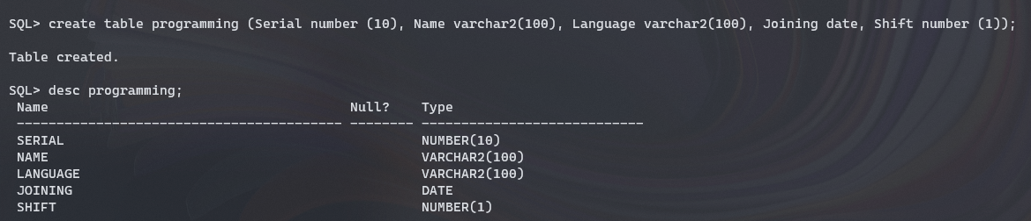

**2.Alter:**

**i) Alter table- Add Column:**

**Syntax:** ALTER TABLE tablename ADD column_name datatype;

**Code:** alter table programming add language_type varchar2(15);

**ii) Alter table-Drop Column:**

**Syntax:** ALTER TABLE tablename DROP column_name;

**Code:** alter table programming drop language_type;

**iii) Alter table-Rename Column:**

**Syntax:** ALTER TABLE table_name RENAME COLUMN oldname TO newname;

**Code:** alter table programming rename column joining to date_of_joining;

**iv) Alter table-Modify Datatype:**

**Syntax:** ALTER TABLE table_name MODIFY column_name datatype;

**Code:** alter table programming serial varchar2(10);

**OUTPUT:**

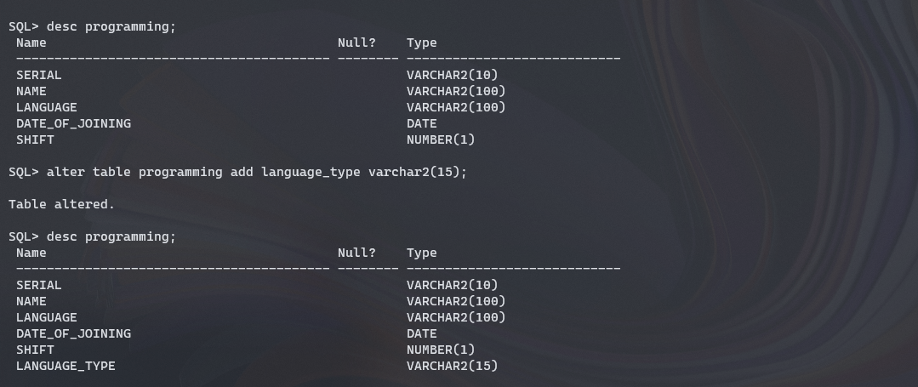

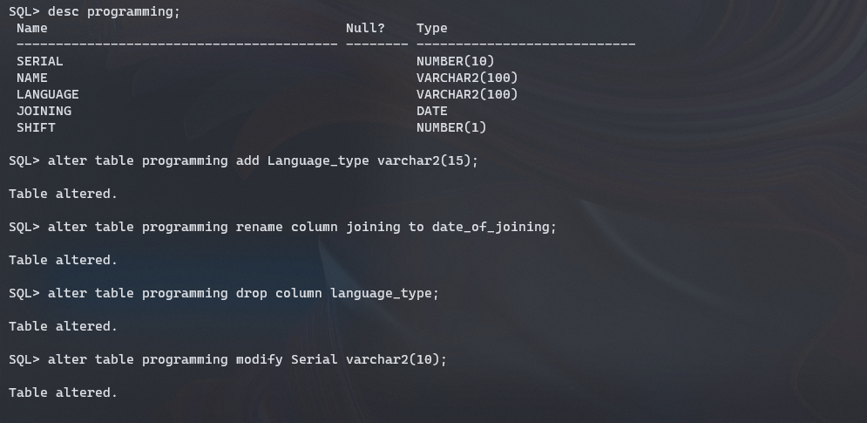

**3.Rename:**

**Syntax:** RENAME old_name to new_name;

**Code:** Rename programming to programming_class;

**OUTPUT:**

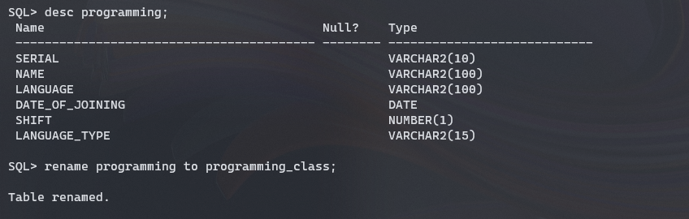

**4.Truncate**

**Syntax:** TRUNCATE TABLE table_name;

**Code:** truncate table programming_class;

**OUTPUT:**

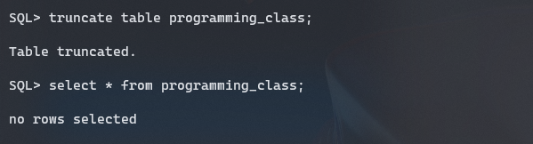

**5.Drop**

**Syntax:** DROP TABLE table_name;

**Code:** drop table programming_class;

**OUTPUT:**

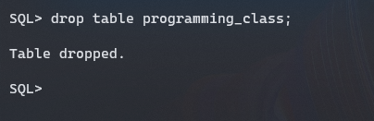

**RESULT:**

Thus the DDL Commands has been executed successfully